**Join Us and Volunteer with**

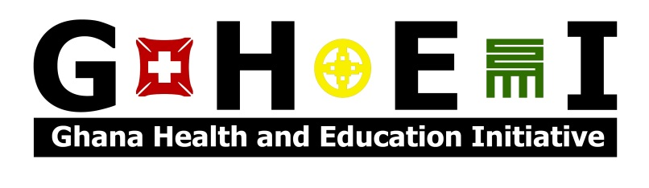

***Invest in an Individual, Empower a Community***



*Summer Serve and Learn 2016:*

**Community Health Evaluation**

Session 1: June 1st – June 17th

**Girls’ Empowerment**

Session 2: July 13th – July 29th

**Application deadline: January 15th 2016**

Preference will be placed on early applications.

The Summer Serve and Learn Volunteer program offers a once-in-a-lifetime experience in international development work in Africa. Our work is grounded in the communities we serve, and by volunteering you will gain profound insight into life in rural Ghana.

**ghei.apply@gmail.com www.ghei.org**

*GHEI is a 501©3 registered NGO working in the rural Western Region of Ghana to improve children’s health and education outcomes through sustainable development practices and community empowerment.*