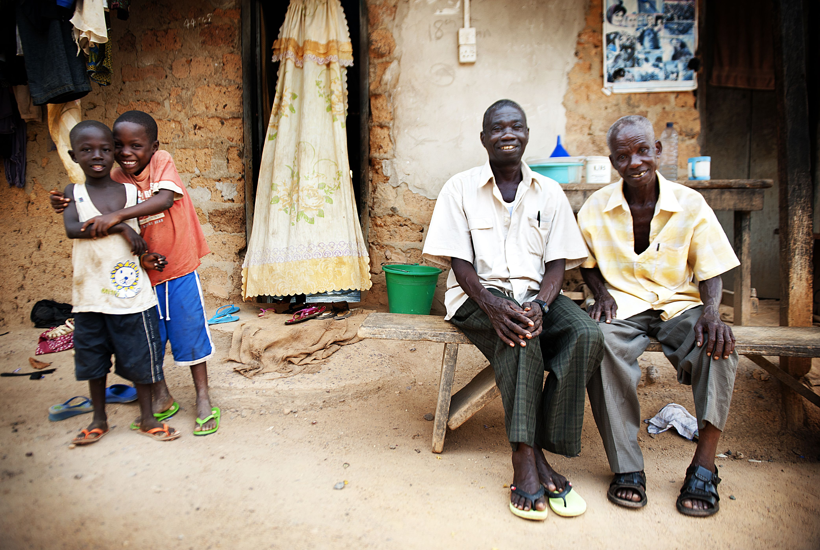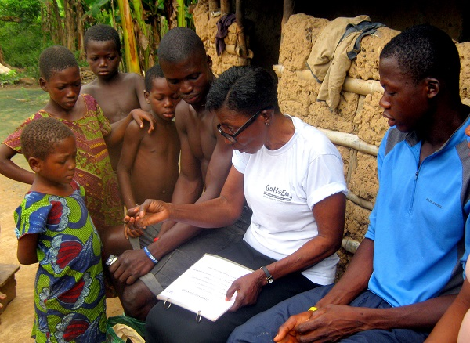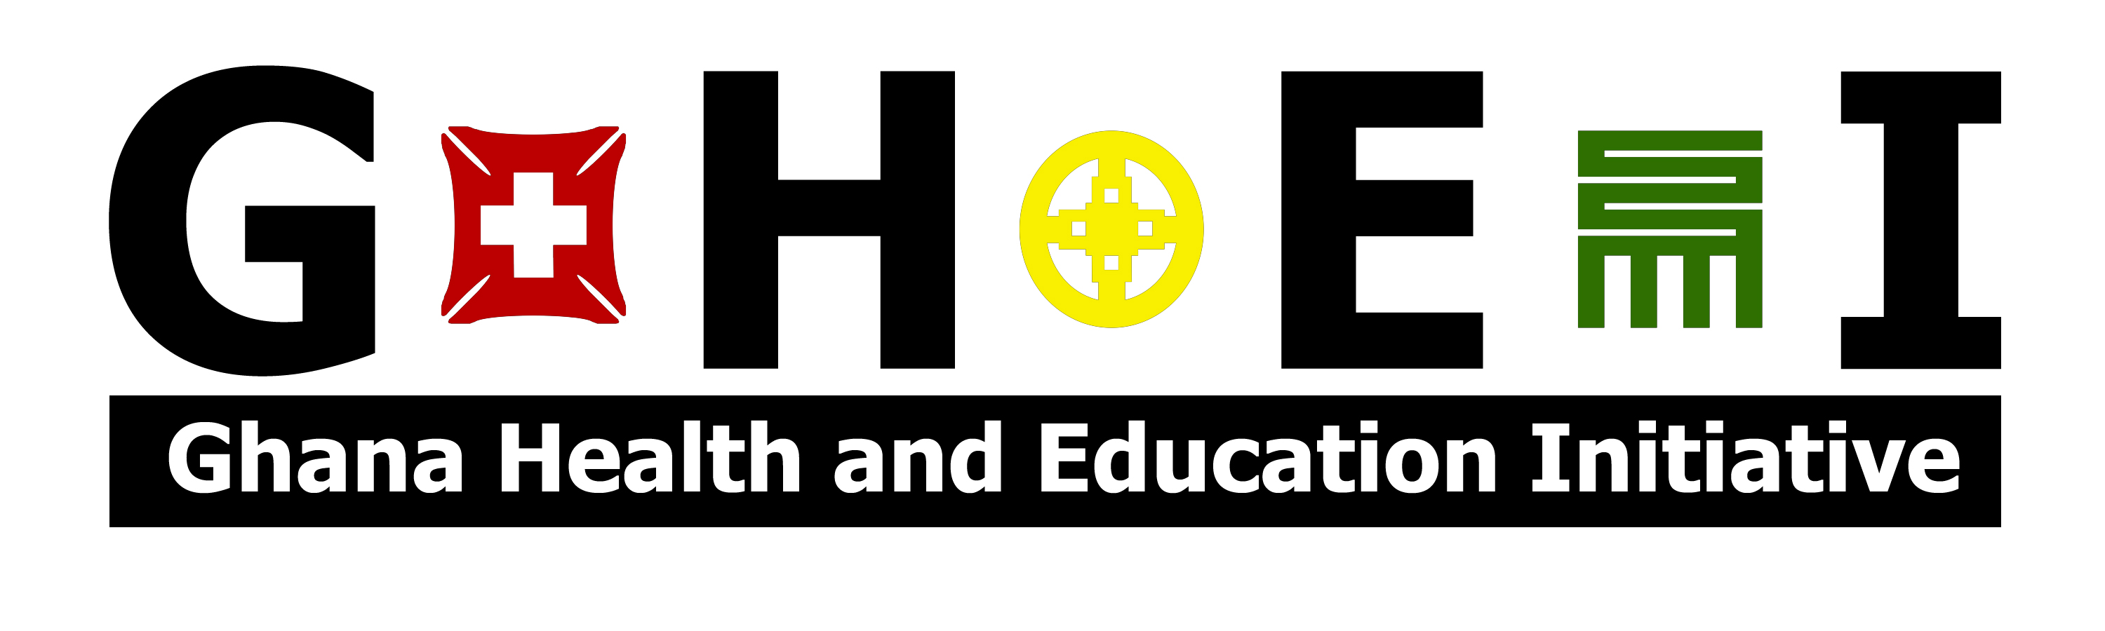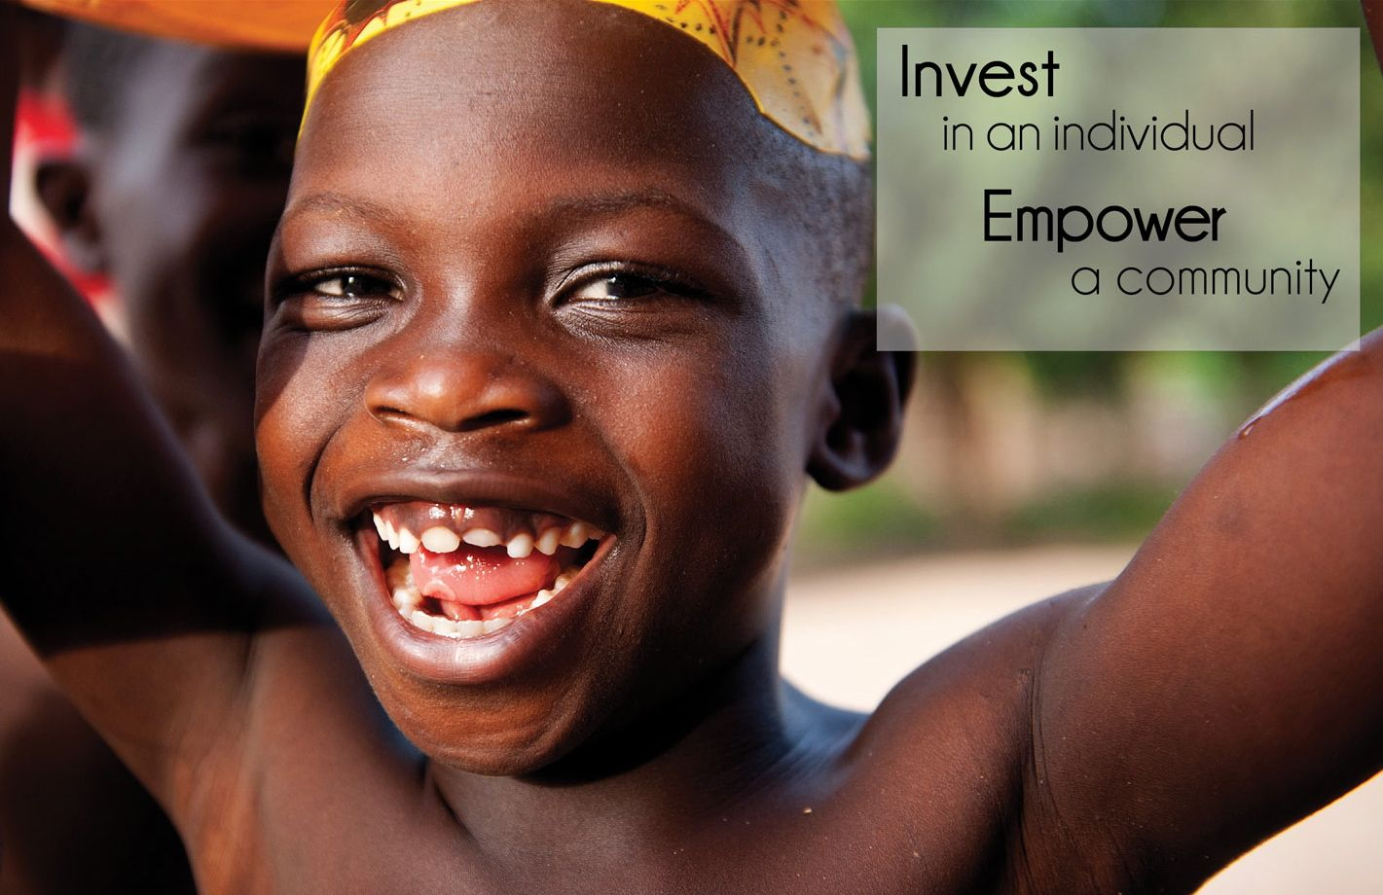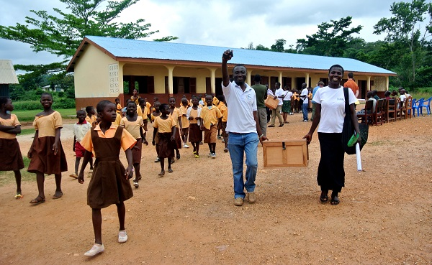

Founded in 2001 by Clement Donkor and Dr. Diana Rickard, GHEI is based in the village of Humjibre, in the Western Region of Ghana. Humjibre is home to over 4,500 people, the majority of whom are small-scale cocoa farmers.

We envision a future where children- free from illness and illiteracy- can realize their full potential, a future in which healthy, educated young people will lead their communities out of poverty.

We believe that implementing high quality programs requires integrity, hard work, and creativity, and we are committed to finding the most innovative solutions, even if it requires challenging established limits.

Our success is firmly rooted in the idea that local capacity leads to sustainability. Therefore we recruit, train, and employ people directly from the communities where we work. GHEI invests in our local team for the same reason we invest in the children and young people we serve: we believe that to invest in an individual is to empower a community.

We believe that implementing high quality programs requires integrity, hard work, and creativity, and we are committed to finding the most innovative solutions, even if it requires challenging established limits.

**GHEI Humjibre**

**PO Box 53**

**Sefwi Bekwai**

**Western Region, Ghana**

**www.ghei.org**

Join us to build a sustainable future in Western Ghana

www.ghei.org

## **Health**

## **Education**

GHEI’s **Community Health Evaluation** program provides bednets either for free or at a highly subsidized price, and relies on our staff of dedicated community health workers to provide household-level bednet education and support. The **Handwashing with Soap** program works at eight local schools to promote proper handwashing with soap, which has been shown to be the best way to prevent common communicable diseases. To support **Sexual and Reproductive Health**, GHEI partners with local businesses and community volunteers to conduct youth-friendly subsidized condom sales. Our **Health Facility Delivery Incentive Program** provides incentive packages to expecting mothers which are designed to reduce the financial burden of delivering in a health facility rather than at home.

Finally, GHEI health staff work with local practitioners to identify other sectors where they can offer expertise, resources or support, and strive to help meet those needs.

Our **Youth Education Program** and **Early Childhood Literacy** programs offer supplemental afterschool classes in a small group setting to enrich top junior high school and poorly performing primary school students respectively. The GHEI-sponsored **Humjibre Community Library** is open to the community six days a week and boasts a collection of over 6,200 books with a special emphasis on children’s storybooks and African-authored books. To date, GHEI’s **Scholarship Program** has awarded 78 senior high school scholarships to local deserving students and boasts a 97% retention rate. In order to overcome cultural barriers to female education, GHEI sets aside additional spaces in its programs for girls. **60%** of our scholarship recipients, Youth Education Program and Early Childhood Literacy classes are female.

Every summer, GHEI welcomes international volunteers to work alongside our local staff in completing projects that both support our year-round programming and complement the skills and expertise of our volunteers. They take part in 16-day sessions which include project work, planned cultural activities and full immersion in a rural Ghanaian community.

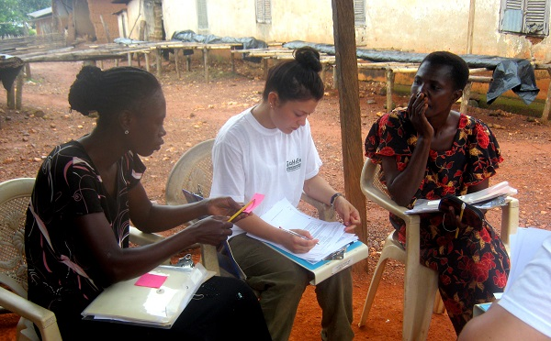

*To learn more about volunteering with GHEI, or any of our other programs, please visit our website at www.ghei.org.*

## **Summer Serve and Learn**

All individuals have a right to health and education. Healthy, well-educated young people have the power to lead their communities out of poverty.

# **Invest** in an individual **Empower** a community.